

**Microsoft SQL Backup**

**Plugin Configuration Guide**

Contents

Microsoft SQL Backup Configuration Checklist 2

Supported Collection Types 2

Data Sources 2

Requirements 2

User Account 2

Firewall Ports 3

Setup 3

Server Properties 3

Field Definitions 4

SQL User Creation 4

Add User: bocada-reporting 4

Alter Instance Permissions 6

Update Securables on master 7

Update Securables on msdb 10

Reporting Notes 11

Troubleshooting 12

Technical Support 13

# Microsoft SQL Backup Configuration Checklist

This checklist is an overview of the steps required to configure Microsoft SQL Collections on your Bocada Data Collection Server.

* Connection to Microsoft SQL Server instance
* Create user with required credentials for read access to msdb and execute privileges for *sys.xp_readerrorlog*.

# Supported Collection Types

The plugin currently supports the following collection types from Microsoft SQL servers:

|  |  |  |
| --- | --- | --- |
| **Collection Type** | **Supported** | **Description** |
| Backup | ✓ | Collects transactional details about backup, duplication and restore jobs. Example metrics include, start times, durations, bytes, files, errors etc. |
| Storage |  | Collects point-in-time inventory information. Example metrics include, total recoverable gigabytes (storage), media volume count, media volume status, etc. |
| Policy |  | Collects and stores information on policy attributes, schedules, storage units, storage groups, storage lifecycle policies and clients. |

# Data Sources

The plugin relies on the following Microsoft SQL data sources:

* MSSQL Sever Backup and Restore Tables (Transact-SQL)
* Microsoft SQL Server log files

# Requirements

This section lists requirements that must be met before collecting data with the Bocada plugin for Microsoft SQL. Details steps to create the Bocada user can be found in the SQL User Creation section

### User Account

User account with access to Microsoft SQL Server through Windows authentification or SQL authentification with the following permissions:

* Server Role: *public*
* System Database User Mapping
  + master: *db_datareader*, *public*
  + msdb: *db_datareader*, *public*, *SQLAgentReaderRole*
  + tempdb: *db_datareader*, *public*
* Instance Permissions
  + *Alter trace*
  + *Connect SQL*
  + *View any definition*
  + *View server state*
* System Database Securables

master: *xp_readerrorlog*, *xp_enumerrorlogs* (execute)

msdb: *sp_help_job* (execute)

Alternatively, a user can be used which has the *security_admin* or *sysadmin* role.

### Firewall Ports

|  |  |  |
| --- | --- | --- |
| **Service** | **Default Port** | **Note** |
| *SQL Server* | 1433/TCP | If you have a designated port for the default instance of SQL Server then that port must be open |
| *SQL Server browser* | 1434/UDP | Not required when SQL port specified |

The TCP port for a default instance of SQL Server is 1433

# Setup

### Server Properties

Backup Server Properties determine how the plugin will interface with the MSSQL Server Instance:

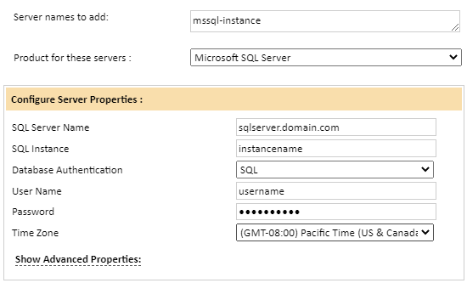

### Field Definitions

#### Server name

Enter your preferred name for the server and instance being monitored. This must be unique so consider which instances will be monitored and name accordingly. For named SQL instances the suggested entry is *sqlshortname_instancename*.

#### SQL Server Name

Network name, or IP address, of your SQL Server. If you leave this entry empty, then the plugin will use the Server name entry from the above box.

#### SQL Instance

Provide SQL instance for backup monitoring. Leave blank for default SQL Server instance.

#### Database Authentication

Choose SQL or Windows Authentication depending on the type of User that will be used to access the Microsoft SQL instance.

#### User Name / Password

Enter the credentials for the SQL or Windows authenticated user that has the required permissions as described in the Requirements section.

#### Time Zone

Select the time zone where Microsoft SQL Server resides. This setting ensures times are displayed consistently in environments that span multiple time zones.

# SQL User Creation

The Bocada plugin requires read access to the MSDB system database as well as permission to execute XP_readerrorlog. A user with *security_admin* or *sysadmin* role will work fine, but the following steps detail the method of creating a user with the minimal permission through SQL Server Management Studio.

### Add User: bocada-reporting

1. Right click Security->Logins, select ‘New Login…’
   * Enter Login name: *bocada-reporting*
   * Select SQL Server Authentication
   * Enter desired password
   * Disable Password expiration

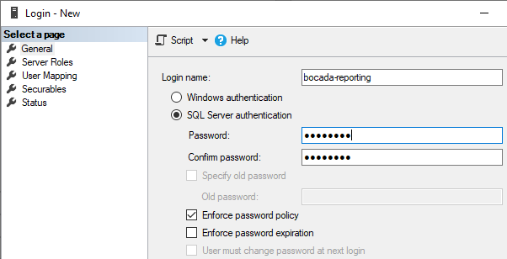

1. Select Server Roles page
   * Ensure the ‘public’ role is selected.

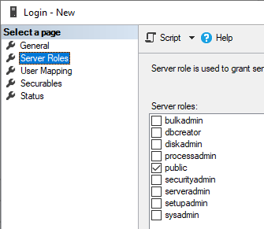

1. Select User Mapping page

Master:

* + db_datareader
  + public

tempdb:

* + db_datareader
  + public

msdb:

* + db_datareader
  + public
  + SQLAgentReaderRole

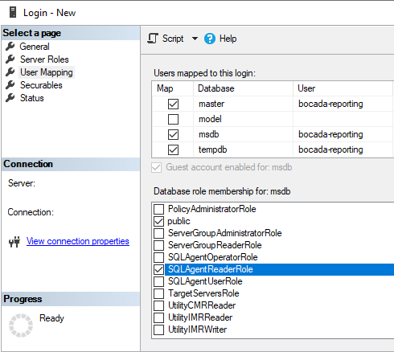

1. Select OK To create *bocada-reporting* user

### Alter Instance Permissions

1. Right click the root in the Object Explorer (the instance), select ‘Properties’
   * Select the Permissions page
   * Click *bocada-reporting* in the Logins or roles list.
   * Ensure the following permissions have the ‘Grant’ checkbox ticked:
     + *Alter trace*
     + *Connect SQL*
     + *View any definition*
     + *View server state*

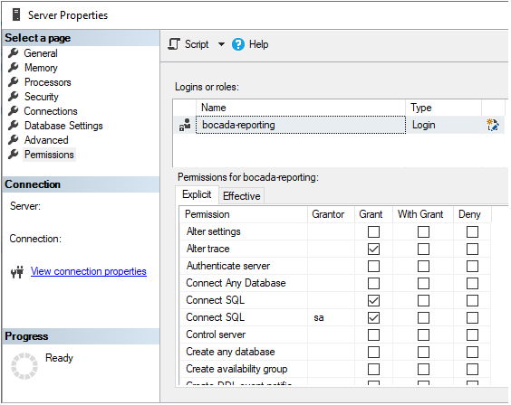

1. Click OK to save permissions

### Update Securables on master

1. Expand Databases -> System Databases -> master -> Security -> Users
   * Right click user: *bocada-reporting*, select ‘Properties’
   * Select the ‘Securables’ page, click: ‘Search…’
   * Select: ‘Specific Objects…’, click OK
   * Click: ‘Objects Types…’, tick: ‘Extended stored procedures’, click OK

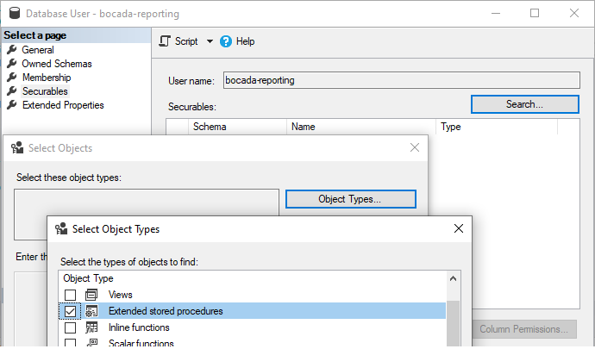

1. In the *Enter the object names to select* box, enter ‘error’, click ‘Check Names’
2. In the search results, tick:
   * ‘xp_readerrorlog’
   * ‘xp_enumerrorlogs’, click OK

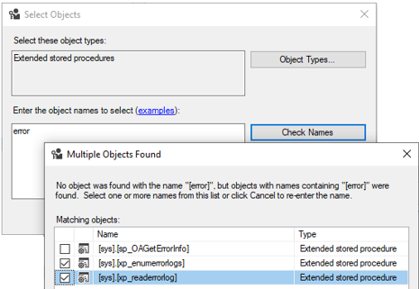

1. Click OK again
2. The selected securables should now be listed under *Securables*
3. Ensure Grant is ticked for the Execute permission for each securable:

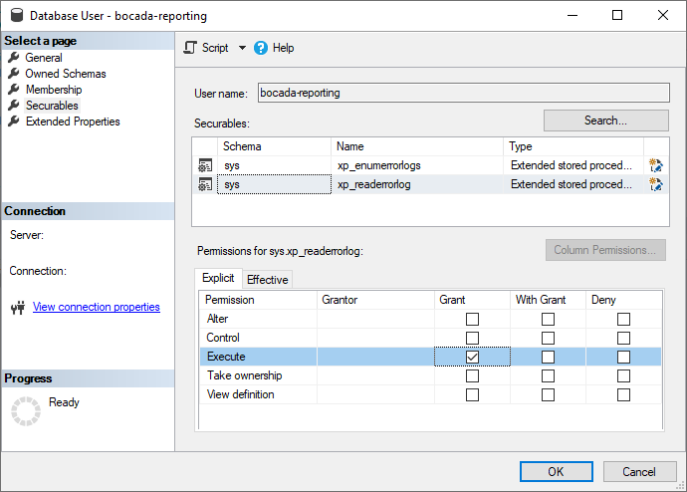

1. Click OK

### Update Securables on msdb

1. Expand Databases -> System Databases -> msdb -> Security -> Users
   * Right click *ocada-reporting*, select ‘Properties’
   * Select the ‘Securables’ page
   * Click: ‘Search…’
   * Select: ‘Specific Objects…’, Click OK
   * Click: ‘Objects Types…’
   * Tick: ‘Stored procedures’, Click OK

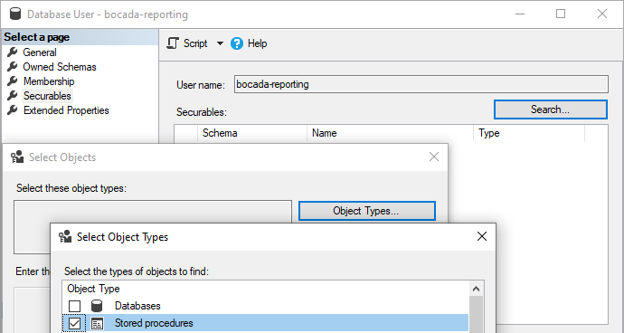

1. In the *Enter the object names to select* box, enter ‘help_job’, click ‘Check Names’
2. In the search results, tick:
   * ‘sp_help_job’, click OK

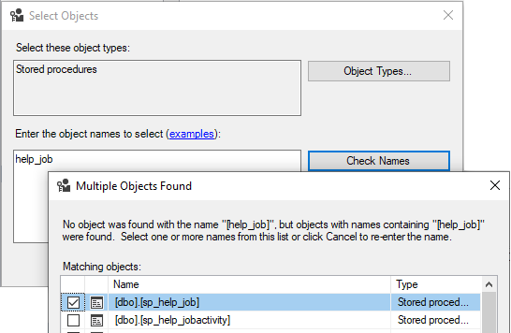

1. Click OK again
2. The selected securables should now be listed under *Securables*
3. Ensure Grant is ticked for the Execute permission for the securable.

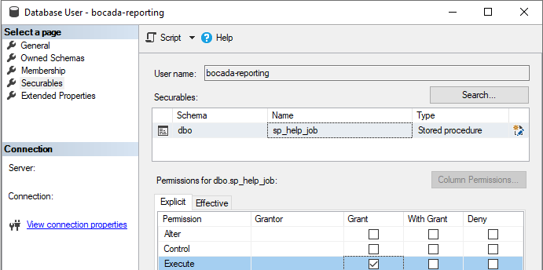

1. Click OK

# Reporting Notes

Some MSSQL plugin specific reporting notes are included below:

#### Database Names Mapped to Client in Bocada Reports

In Bocada reports you will see the name of the SQL Server shown as the *Backup Server*. Each database name will appear in the reports mapped to the Backup Client Name.

#### Databases Not Backed Up are Available in Reports

The SQL Server plugin also mines the names of databases that are not backed up. These can beviewed in the Backup Clients report by running the report to include INACTIVE clients. Keep in mind that the database names are shown as backup client names in Bocada.

Best practice, if it is desired to monitor the not-backed-up databases, is to implement transfer of the list of databases to the Bocada Asset Inventory reports. This is done using the CMDB plugin with self-reference to the Bocada database. Contact Bocada support for assistance.

#### Volume and Media Destinations

* In the Bocada Backup Activity report the columns for **Volume** and **Media Destination** both contain the value from the column in MSDB: **dbo.backupmediafamily.physical_device_name**. You will need to include media volumes in the report as shown in this screenshot:

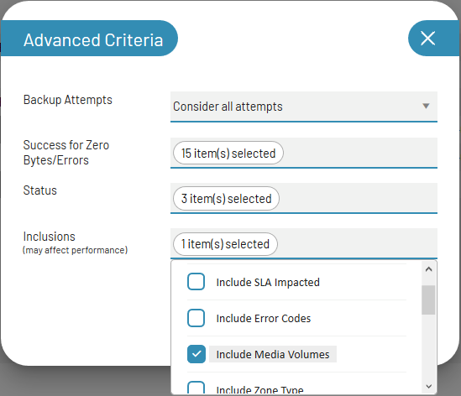

# Troubleshooting

Troubleshooting scenarios are listed here as they are discovered.

# Technical Support

For technical support or a copy of our standard support agreement, please contact us.

**E-mail:** [support@bocada.com](mailto:support@bocada.com)

**Support Portal:** [https://bocada-support.force.com](https://bocada-support.force.com/)

**Phone:** +1-425-898-2400